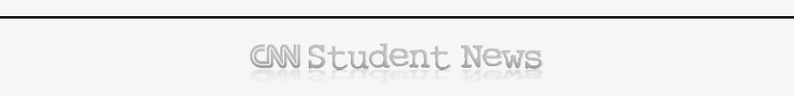

What day is Monday in the USA?
What did the US House vote yesterday?
How big is the money cut?
What has to be done before the president signs the Bill into law?
Read:
There's an even bigger fight brewing over the 2012 budget. Democrats, led by the president, and Republicans, who lead U.S. the House of Representatives, don't see eye-to-eye on how much the government should spend, or tax.
What does “see eye to eye” mean?
What is that they can’t afford according to US President Obama?
What do budget experts say the cuts plan and the deficit?
What would happen if those tax cuts are not renewed?
What are Republicans betting on according to Ron Haskins?
What is the answer to the I D me quiz of the day? Write as much information as you can
What is the big change coming to this Administration? How come these changes are taking place?

What kind of natural event is going on in Texas?
A study just found that reckless driving and alcohol aren't the main reasons for the crashes involving teens. What are then the main causes?

